**Machine Learning Project Documentation**

**Deployment**

**1. Overview**

The deployment phase involved several key steps to make the machine learning model available for use in a real-world or production environment. This included preparing the model for deployment, creating a web interface, creating the backend, and setting up all together ready for the user to explore. The goal was to ensure that users could interact with the model seamlessly and securely.

**2. Model Serialization**

The trained model was serialized using Python's pickle module, which allows the model to be saved in a binary format. This format was chosen for its simplicity and ease of use with Python-based applications. The serialized model was stored as a model2.pkl file. This process ensures that the model can be easily loaded and used for predictions without the need to retrain it every time.

**3. Model Serving**

The serialized model is served using a Flask web application. Flask is a lightweight WSGI web application framework in Python, making it an excellent choice for deploying machine learning models in a simple and scalable way. The Flask app loads the serialized model and provides endpoints for making predictions. The model is hosted on a local server, but it can be easily adapted to run on cloud platforms such as AWS, Google Cloud, or Azure for better scalability and availability.

Frontend:  
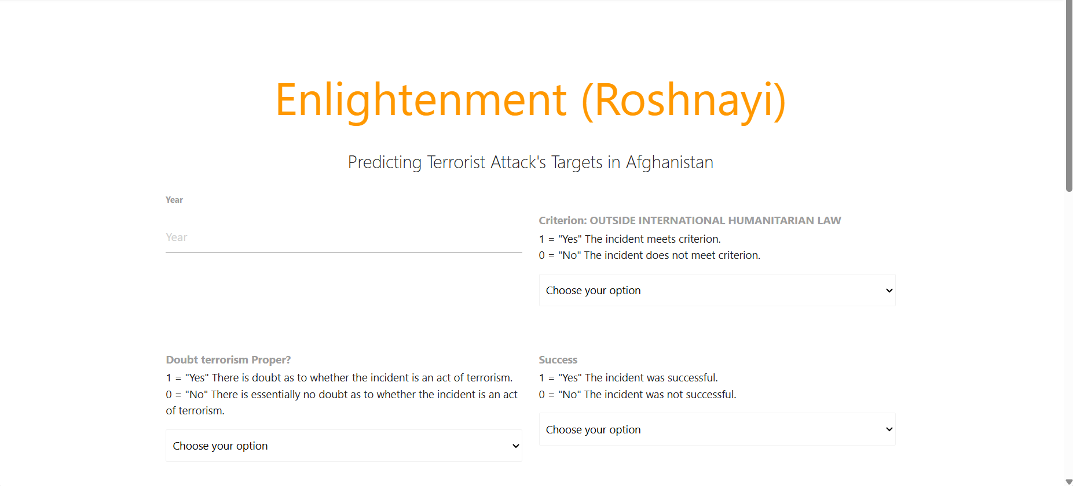

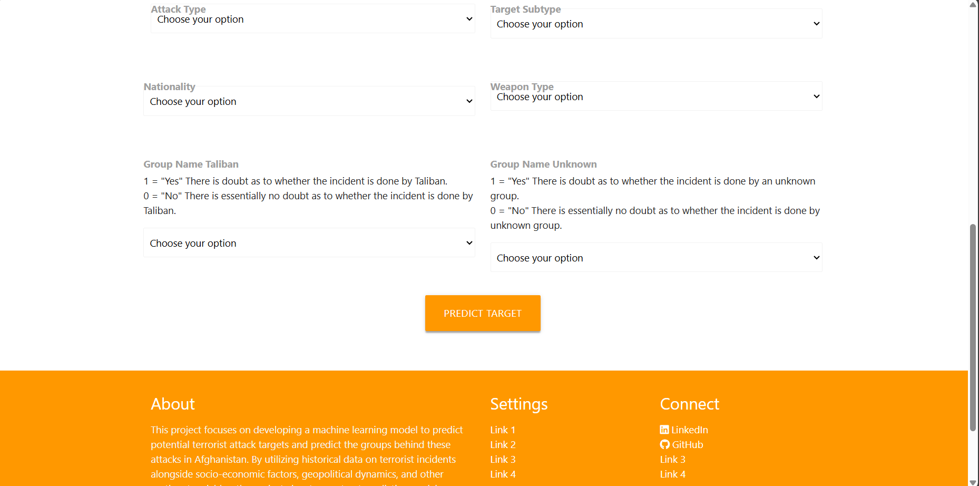

I need to mention that the frontend is ready to be used but I will apply some changes to make it more interactive and well looking.

**4. API Integration**

The machine learning model is integrated into an API to facilitate easy access. The Flask application defines a /predict endpoint that accepts POST requests with input features. The input is processed and passed to the model for prediction. The API then returns the prediction result in a user-friendly format. The / endpoint serves an HTML form where users can input features and receive predictions directly from their browser. This integration ensures that the model can be accessed programmatically or through a web interface.

**5. Security Considerations**

As the model deployed locally there is not much security considerations for now but ensuring that the input features are correctly formatted and within expected ranges to prevent malicious inputs can be a security consideration which is well managed in this project.

**6. Monitoring and Logging**

The deployed model's performance is monitored through logging mechanisms. The Flask application logs each request and prediction result, which helps in tracking the model's usage and identifying any potential issues. Key metrics such as response time, number of requests, and error rates are tracked.